**Pre-Lab 3:**

**Second Order Circuit**

Name: Wan-Yu Liao

ECEN 325 Section 514

TA: Mandela

Date: September 20, 2019

**Calculation**

1. Read the data sheet for the UA741 opamp and write down the typical values of the following parameters:

|  |  |  |  |
| --- | --- | --- | --- |
| Supply Voltage: | 5V to 15V  -5V to -15V | Power Consumption: | 50mW |
| Input Resistance: | 2MΩ | Input Offset Voltage: | 1mV |
| Output Resistance: | 75Ω | Input Offset Current: | 20nA |
| Voltage Gain: | 106dB | Bandwidth: | 1MHz |
| Slew Rate: | 0.5V/μs |  |  |

1. Derive the voltage gains

Circuit A

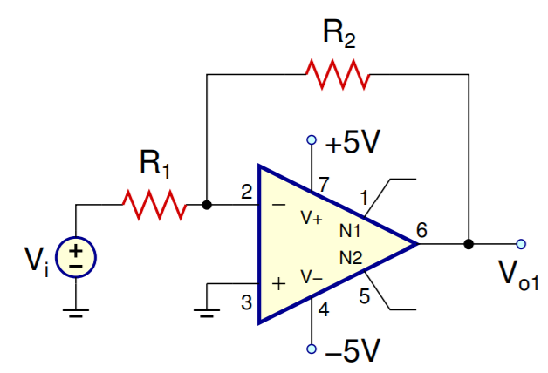

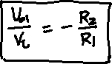

Circuit B

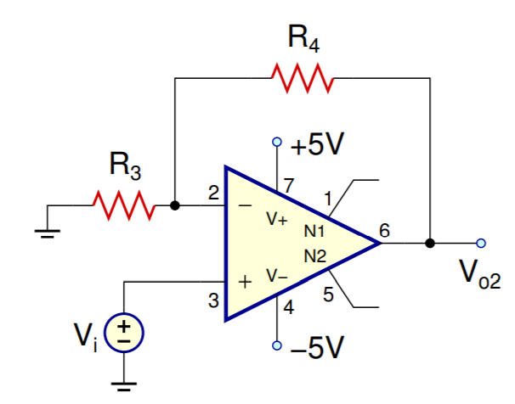

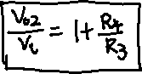

Circuit C

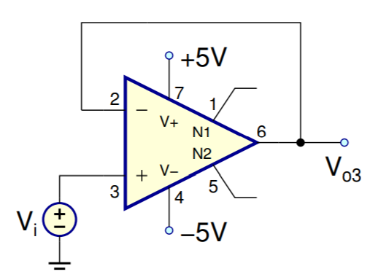

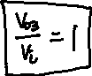

1. If R1 = R3 = 10kΩ, find R2 and R4 such that Vo1/Vi =−3 and Vo2/Vi = 6.

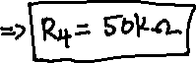

**Simulations**

Circuit A





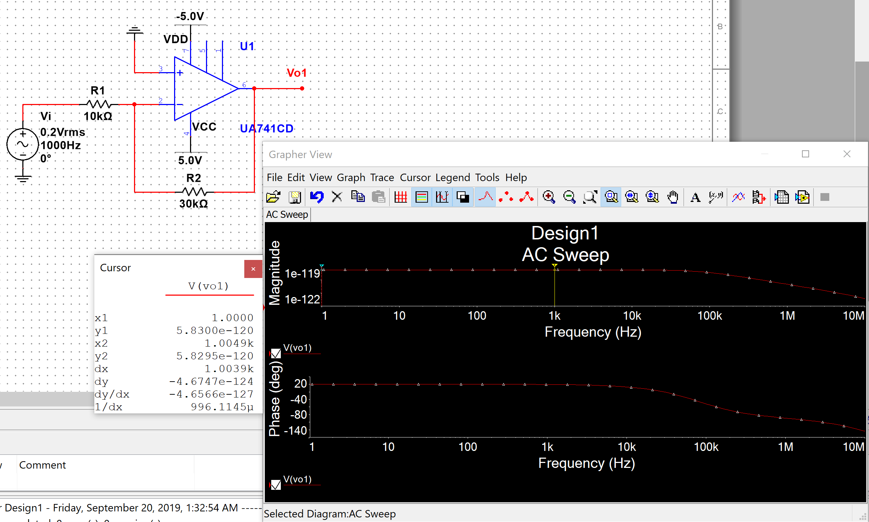

(b)

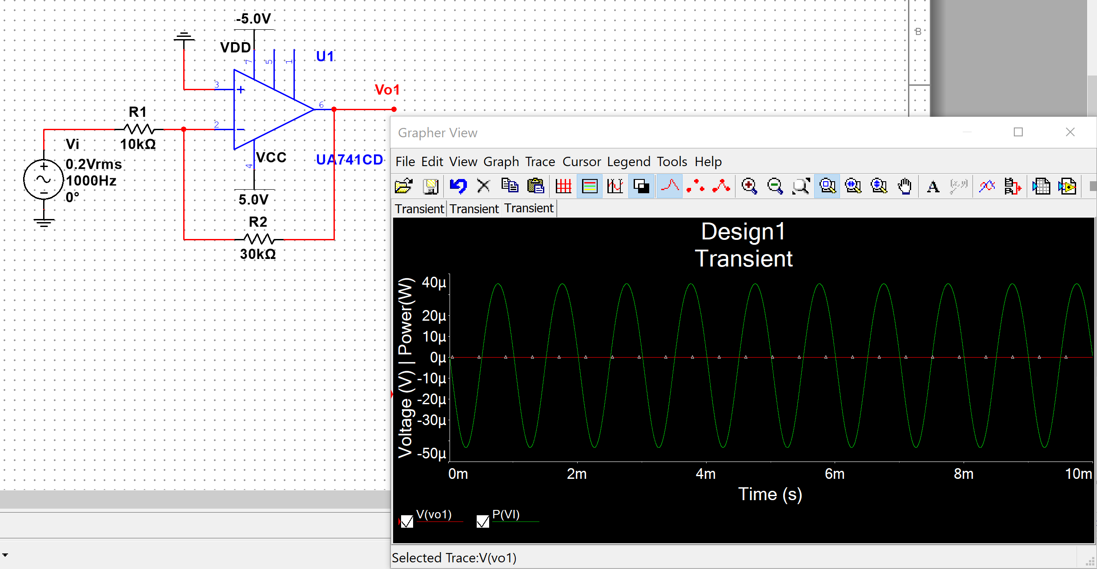

(c)

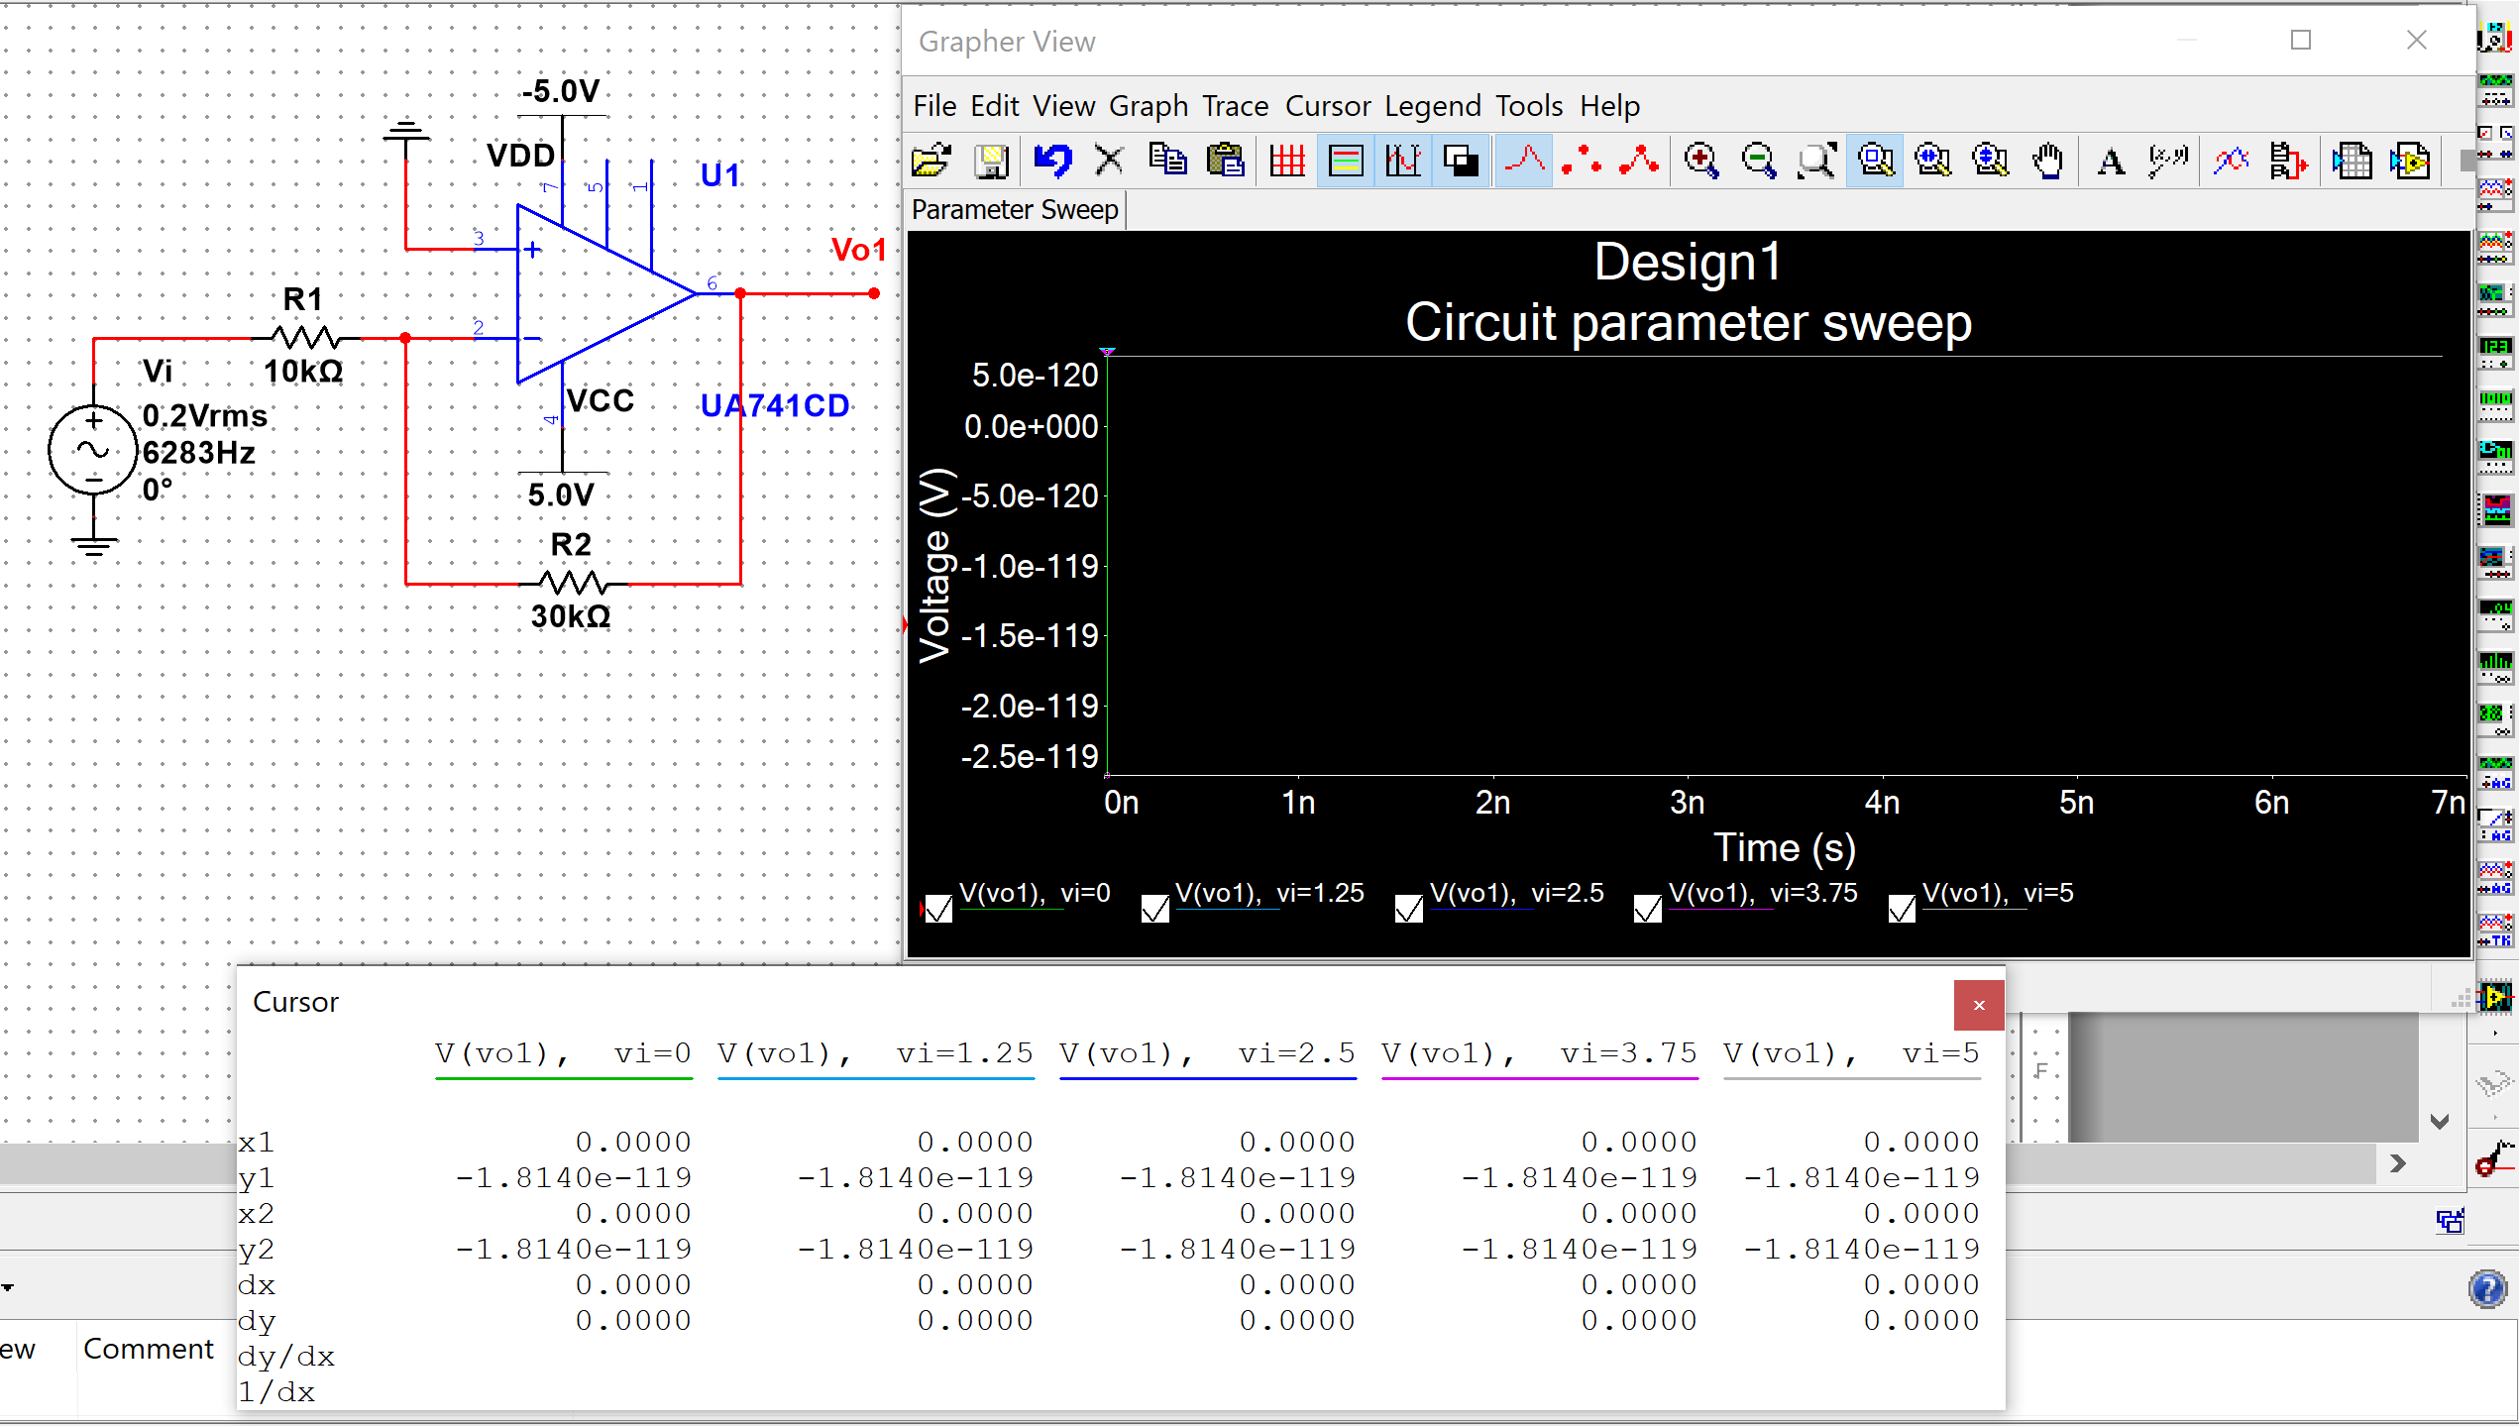

(d)

Since I couldn’t tell the Vmax from the graph above. I searched online and used 1.15V as the Vmax for this circuit. Still couldn’t figure out why there is nothing on the graph.

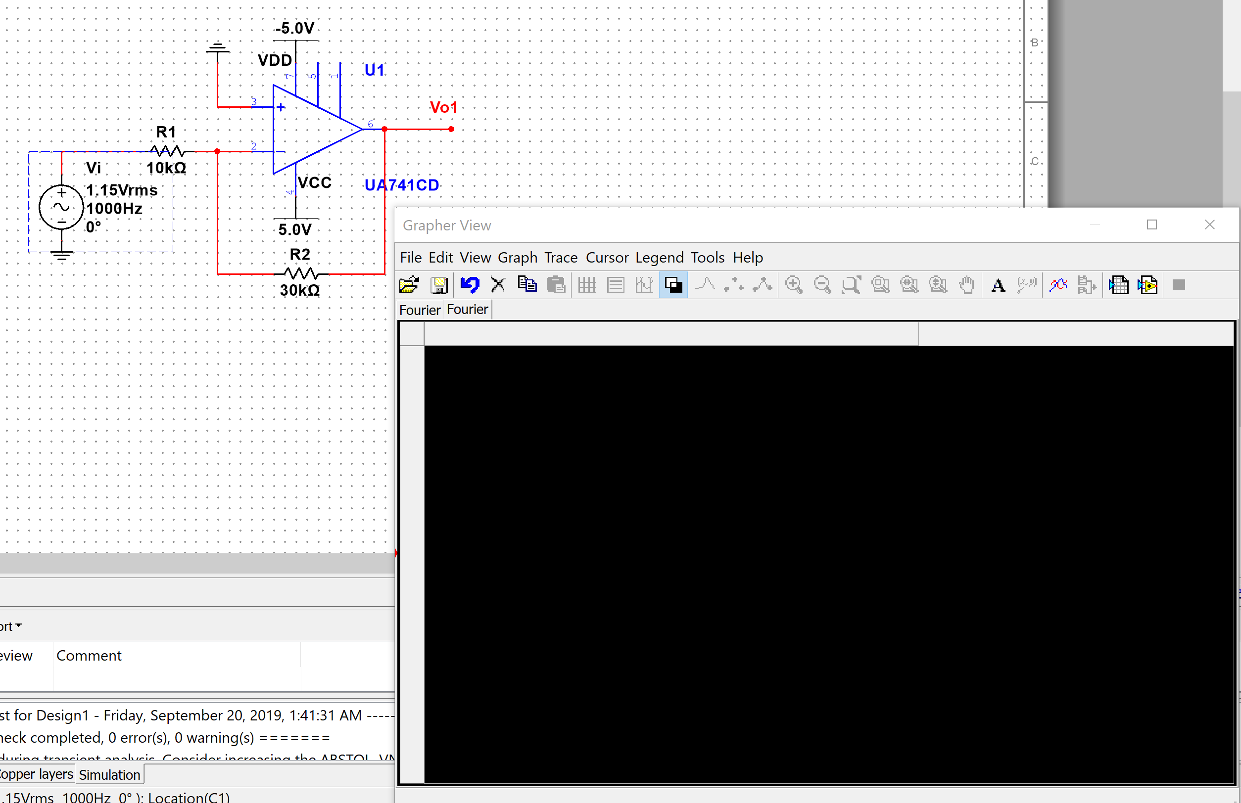

Circuit B

(a)

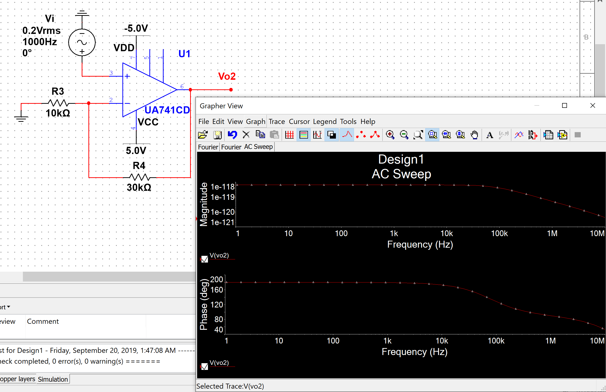

(b)

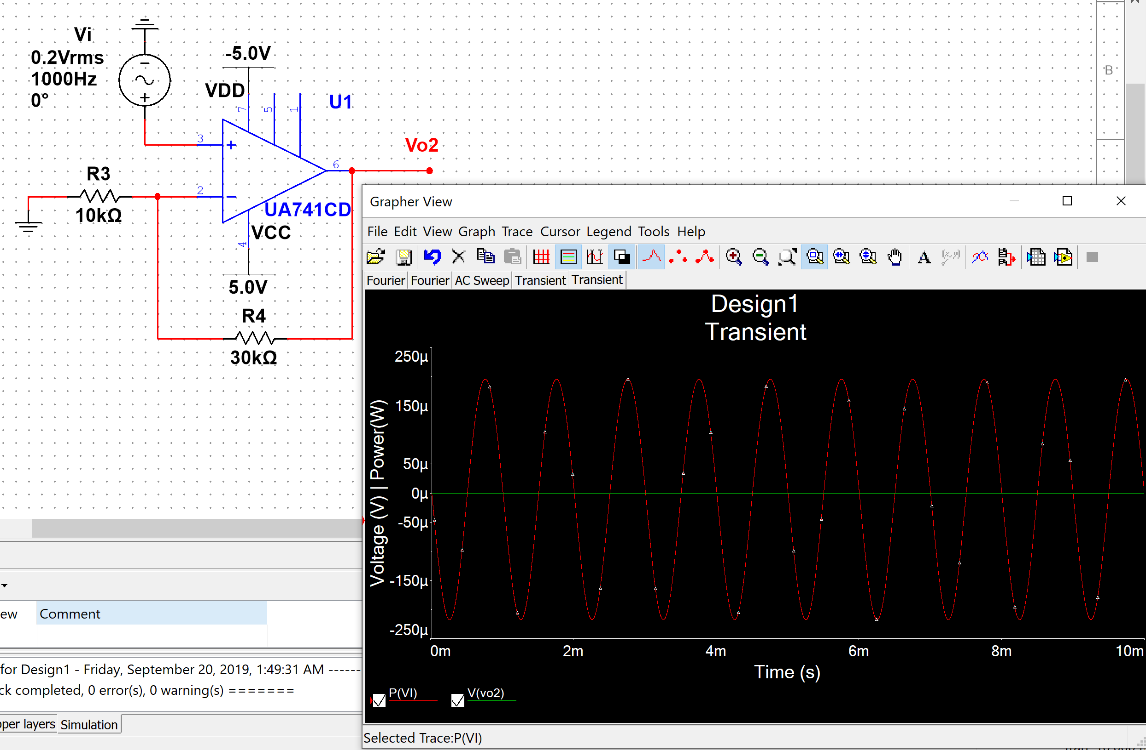

(c)

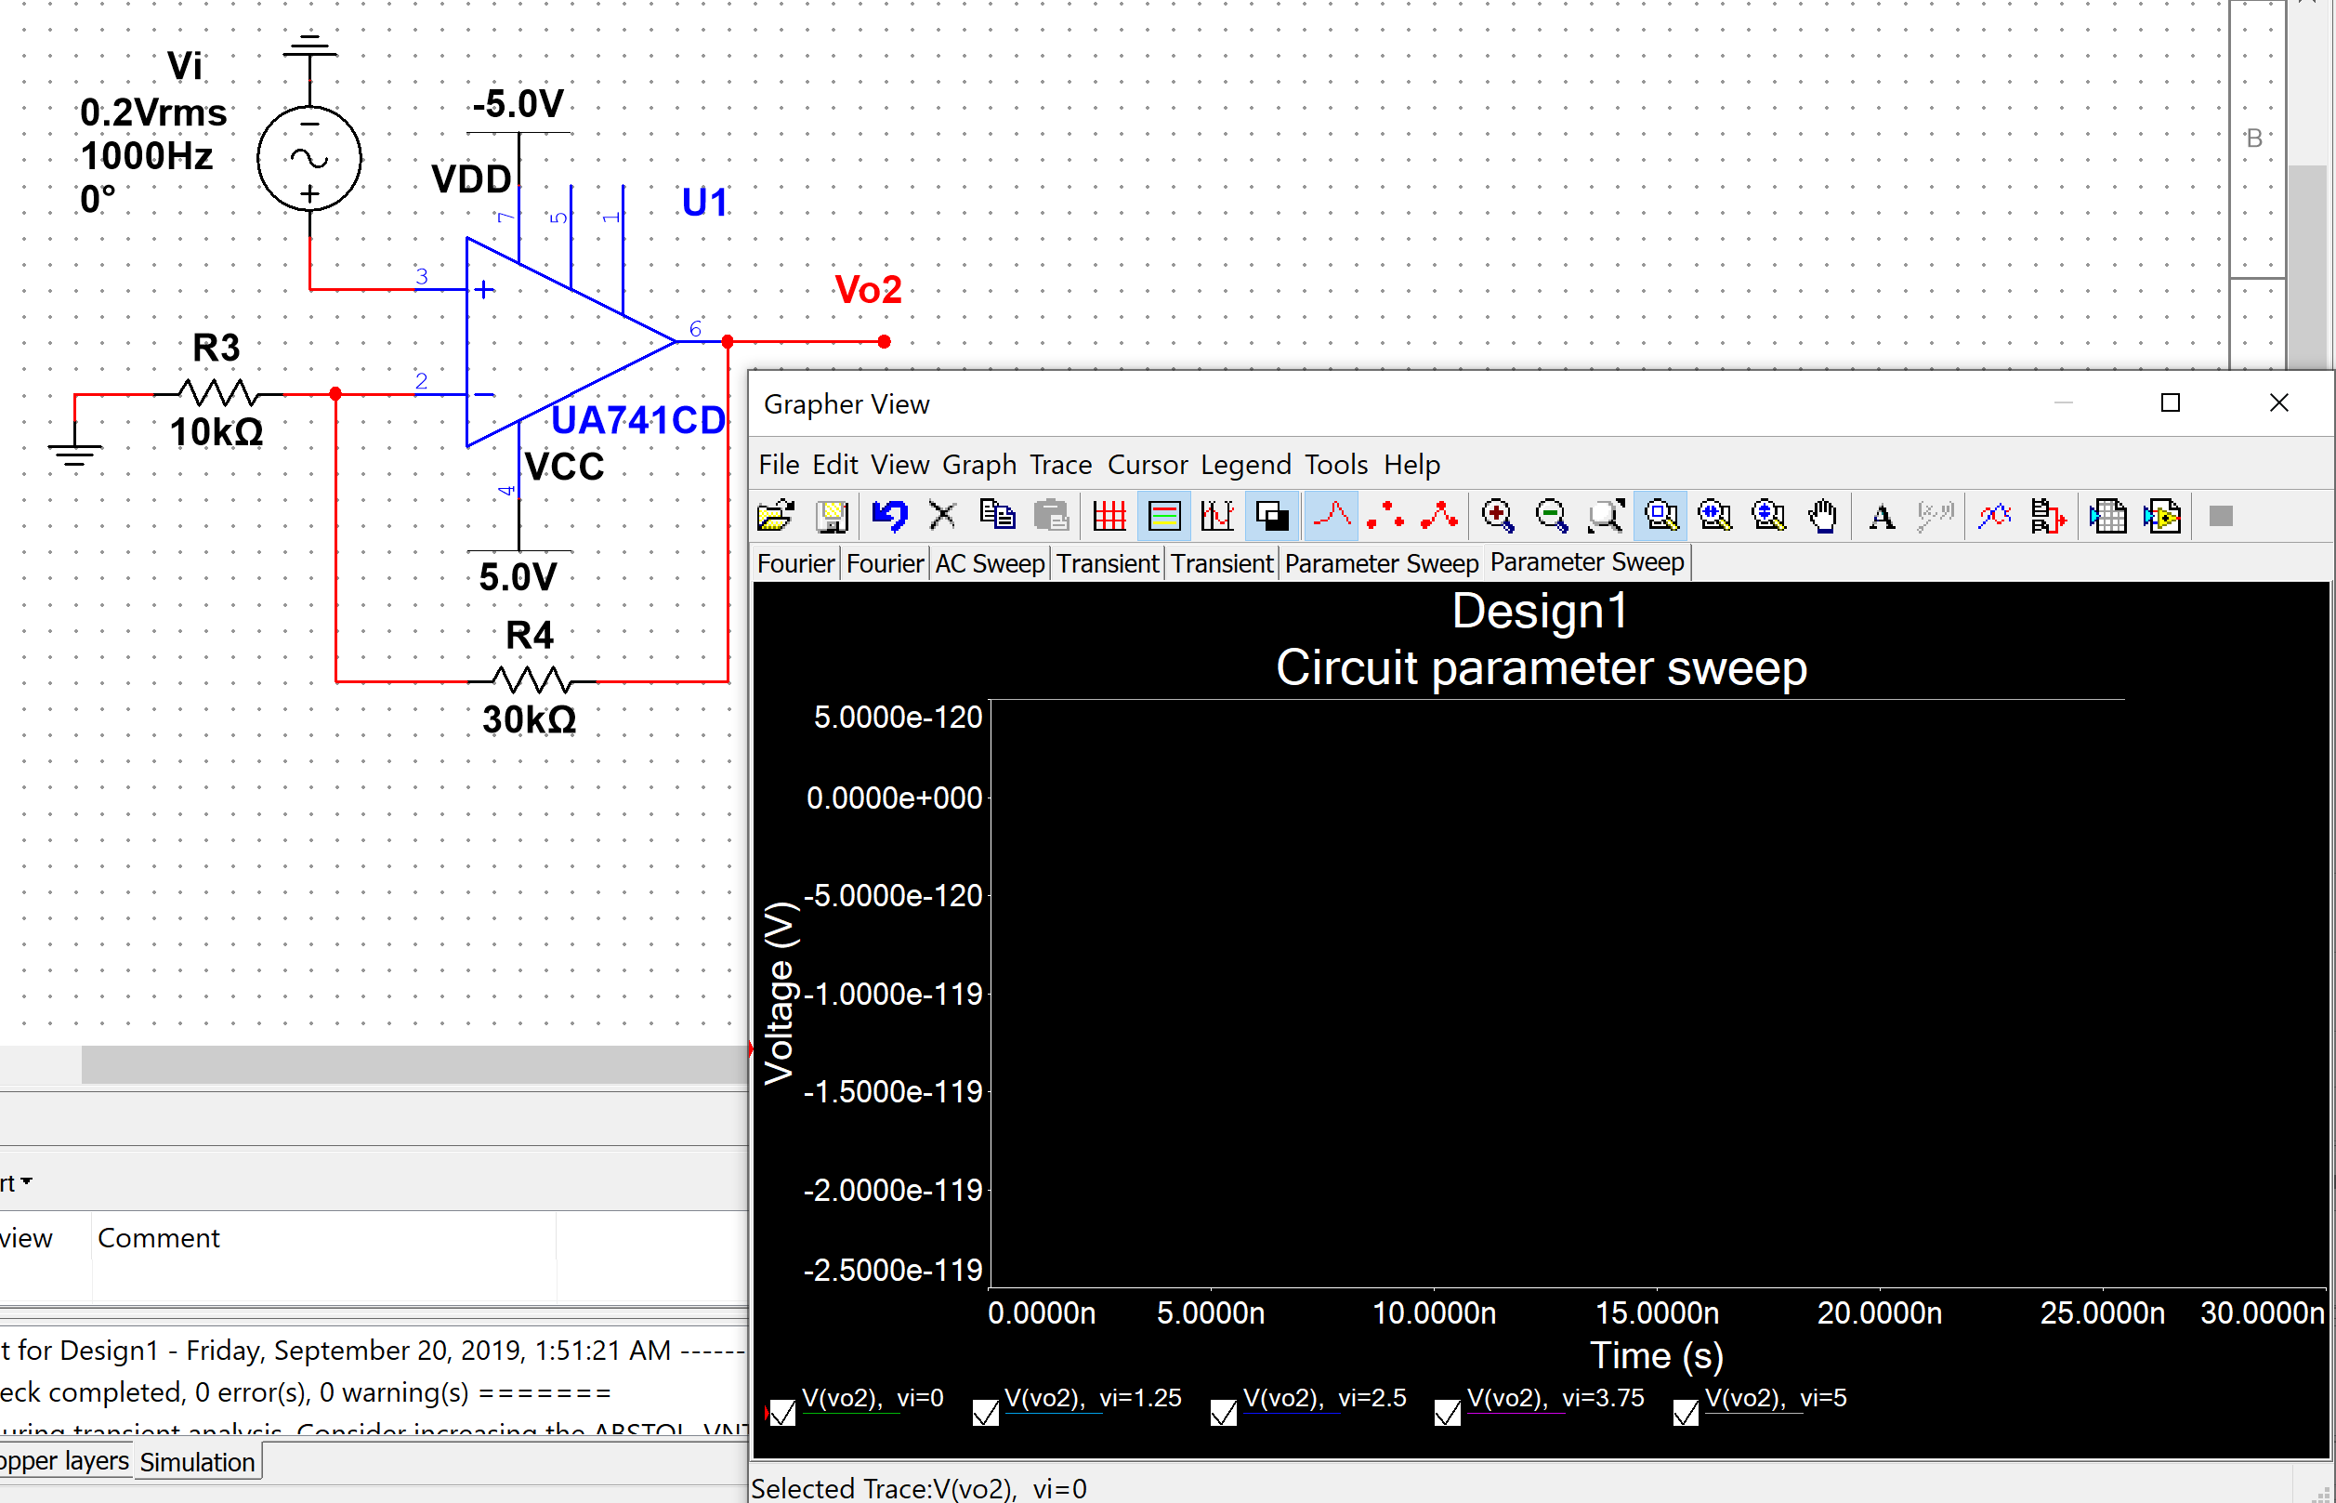

(d)

Since I couldn’t tell the Vmax from the graph above. I searched online and used 1.25V as the Vmax for this circuit. Still couldn’t figure out why there is nothing on the graph.

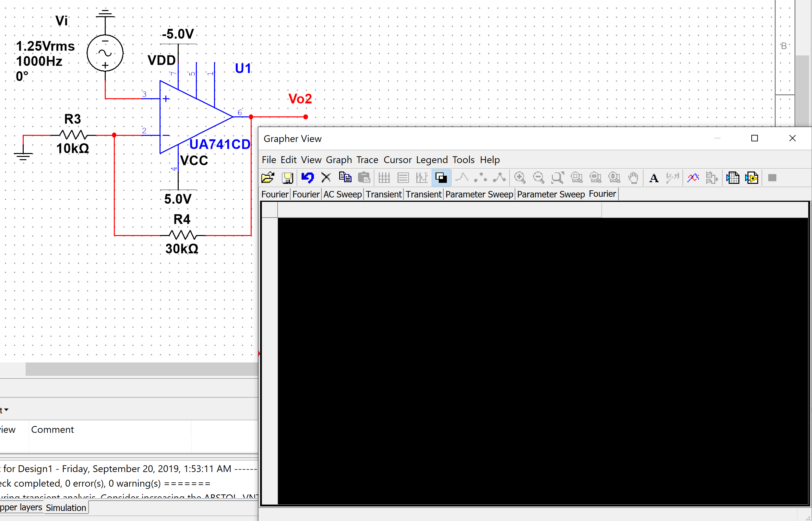

Circuit C

(a)

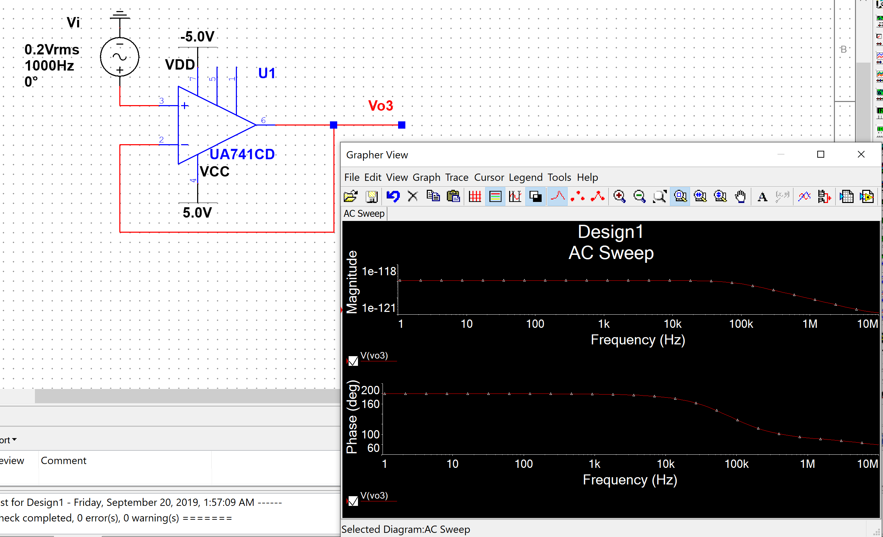

(b)

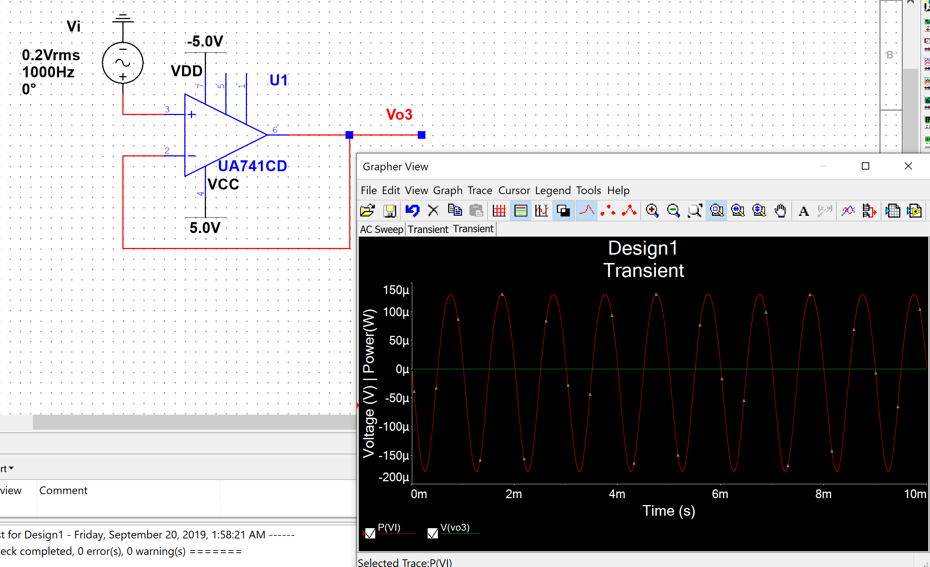

(c)

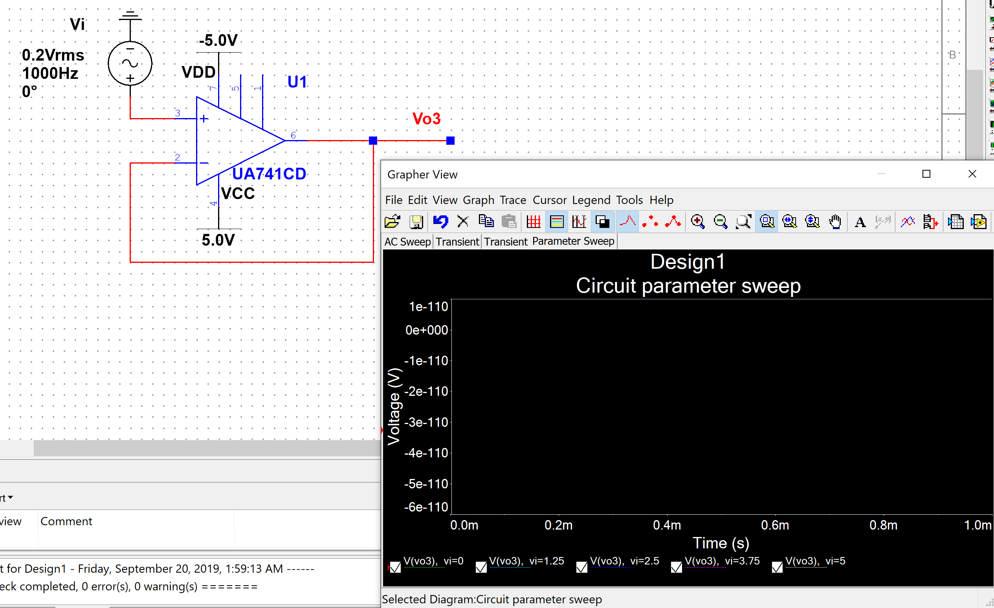

(d)

Since I couldn’t tell the Vmax from the graph above. I searched online and used 1V as the Vmax for this circuit. Still couldn’t figure out why there is nothing on the graph.

